**PART A**

(Part A: TO BE REFERRED BY STUDENTS)

**Experiment No. 02**

**A.1 AIM:**

Study of Basic HTML tags & create webpages for any website using HTML tags.

**A.2 Pre requisite:**

Basic Knowledge of HTML and HTML tags.

**A.3 Outcome:**

After successful completion of this experiment students will be able to:

1. Design pages in HTML
2. Perform all formatting of text and images in HTML
3. Create tables and lists in HTML
4. Design interactive pages in HTML using Frames
5. Use various properties of Frames

**A.4 Theory:**

**What is HTML?**

HTML is a language for describing web pages. HTML stands for Hyper Text Markup Language. HTML is a markup language. A markup language is a set of markup tags. The tags describe document content. HTML documents contain HTML tags and plain text. HTML documents are also called web pages.

**HTML Tags**

HTML markup tags are usually called HTML tags. HTML tags are keywords (tag names) surrounded by angle brackets like <html>. HTML tags normally come in pairs like <p> and </p>. The first tag in a pair is the start tag, the second tag is the end tag. The end tag is written like the start tag, with a slash before the tag name. Start and end tags are also called opening tags and closing tags

**HTML Element Syntax**

An HTML element starts with a start tag / opening tag. An HTML element ends with an end tag / closing tag. The element content is everything between the start and the end tag. Some HTML elements have empty content. Empty elements are closed in the start tag. Most HTML elements can have attributes.

**HTML Attributes**

HTML elements can have attributes. Attributes provide additional information about an element. Attributes are always specified in the start tag. Attributes come in name/value pairs like: name="value".

Example :

<**html**>

<**head**>

<**title**>This is a title</**title**>

</**head**>

<**body**>

<**p**>Hello world!</**p**>

</**body**>

</**html**>

|  |  |
| --- | --- |
| **Tags** | **Description • Meaning • Definition** |
| **<a>** | ANCHOR tag creates <a href="http://www.fillster.com">[link](http://www.fillster.com/)</a> to other internet location, or file. |
| **<abbr>** | ABBREVIATION tags indicate interpretation of the meaning to the browsers and search engines for such as kind of abbreviations as "Inc.", "etc.". |
| **<acronym>** | ACRONYM tags defines an acronym, like; <acronym title="World Wide Web">**WWW**</acronym>. |
| **<b>** | BOLD tag is specifying <b>**bold section**</b> within the text document. |
| **<big>** | BIG tag makes the <big>**text larger**</big> then the rest of the text. |
| **<body>** | <body> **Body tags identify the content of a web page.**   </body> |
| **<br>** | Line Break tag is specifying<br> **a new line** |
| **<center>** | <center>**CENTER tags center text, images, etc.**</center> |
| **<em>** | EM tags <em>emphasize</em> text. |
| **<fieldset>** | FIELDSET tag creates a form for all elements in it. <fieldset>Find a rounded-corner box around this text.</fieldset> |
| **<font>** | FONT tags attribute text |
| **<form>** | Form tags define a form. |
| **<frame>** | Frame tags define each frame within a frameset. |
| **<frameset>** | FRAMESET tags define a layout of frames. |
| **<h1>to<h6>** | H1 - H6 define level 1-6 headers. |
| **<head>** | Head tags define general information about the document, page title, meta-tags, scripts and links to follow, and other commands to browsers. |
| **<hr>** | HR tag draws a horizontal break line. |
| **<html>** | HTML tags contain HTML elements, and give a command to browsers to read the document as an HTML document. |
| **<iframe>** | iFrame tag creates an inline frame that contains another web page in it. |
| **<img>** | IMG tag attributes an image. |
| **<input>** | INPUT tags define input fields, check boxes, radio buttons. |
| **<i>** | <I> tag is specifying <i>italic text</i>. |
| **<legend>** | LEGEND tag assigns a caption in a fieldset element. |
| **<li>** | LI tag defines a list of ordered and unordered items. |
| **<link>** | LINK tag defines a link to an external document, such as External Style Sheets. |
| **<marquee>** | MARQUEE tags define different movement behaviors. |
| **<option>** | OPTION tag creates a drop-down menu. OPTION tag works only in conjunction with a SELECT tag. |
| **<ol>** | OL tags define an ordered list of items. |
| **<p>** | <p> tag is specifying a paragraph and creates a new line. |
| **<pre>** | PRE tag is specifing a preformatted text. This tag does,t let the browsers to eliminate "white spaces" in the text. |
| **<script>** | SCRIPT tags define scripts within a web page and let the web browsers know that it's not an HTML section. You can place a <SCRIPT> tag anywhere within HTML, but the best practice is to place it between the <HEAD></HEAD> tags. |
| **<select>** | SELECT tag creates a menu on a form. |
| **<small>** | SMALL tag creates a small text. |
| **<strike>** | STRIKE tag creates a strike through words or text. |
| **<strong>** | STRONG tag is specifying a strong text. |
| **<style>** | STYLE tag specifies a link and location to a style sheet, and gives a command to browsers regarding to a layout for a web page. |
| **<sub>** | SUB tag is defining a subscripted text. |
| **<sup>** | SUP tag is defining a superscripted text. |
| **<table>** | TABLE tag is defining a table. |
| **<td>** | TD tag creates a data cell. |
| **<th>** | TH tag creates a header cell. |
| **<tr>** | TR tag creates a row in a table. |
| **<textarea>** | TEXTAREA tag creates a text area. |
| **<title>** | TITLE tag declares a title of an HTML document. |
| **<u>** | U tag makes an underlined text. |
| **<ul>** | UL tags define an unordered list of items. |

**PART B**

(PART B: TO BE COMPLETED BY STUDENTS)

(Students must submit the soft copy as per following segments within two hours of the practical. The soft copy must be uploaded on the Blackboard or emailed to the concerned lab in charge faculties at the end of the practical in case the there is no Black board access available)

|  |  |
| --- | --- |
| Roll No. : N049 | Name: Tarun Tanmay |
| Class : MbaTech CE | Batch : B3 |
| Date of Experiment : 7/11/20 | Date/Time of Submission : 7/11/20 |
| Grade : |  |

**B.1 Code:**

**SignUp Form HTML Code:**

**<!DOCTYPE html>**

**<html lang="en">**

**<head>**

**<meta charset="UTF-8">**

**<meta name="description" text="Signup Form">**

**<meta name="viewport" content="width=device-width, initial-scale=1.0">**

**<meta http-equiv="X-UA-Compatible" content="ie=edge">**

**<link href = "signupform.css" rel="stylesheet" text="css">**

**<title>**

**SIGN UP Form**

**</title>**

**</head>**

**<body>**

**<div id="container">**

**<div class="form-wrap">**

**<h1>Sign Up</h1>**

**<p>It's free and only takes a minute</p>**

**<form>**

**<div class="form-group">**

**<label for="first-name">First Name</label>**

**<input type="text" name="firstName" id="first-name" placeholder="Enter your first name"/>**

**</div>**

**<div class="form-group">**

**<label for="last-name">Last Name</label>**

**<input type="text" name="lastName" id="last-name" placeholder="Enter your last name"/>**

**</div>**

**<div class="form-group">**

**<label for="Email">Email</label>**

**<input type="email" name="Email" id="email" placeholder="Enter your email address"/>**

**</div>**

**<div class="form-group">**

**<label for="Password">Password</label>**

**<input type="password" name="password" id="password" placeholder="Enter your password"/>**

**</div>**

**<div class="form-group">**

**<label for="password2">Confirm Password</label>**

**<input type="password" name="password2" id="password" placeholder="Enter your password again"/>**

**</div>**

**<button type="submit" class="btn">Sign Up</button>**

**<p class="bottom-text">**

**By clicking the Sign Up Button, you agree to our <br>**

**<a href="#"> Terms & Conditions</a>**

**<a href="#">Privacy Policy</a>**

**</p>**

**</form>**

**</div>**

**<footer>**

**<p>**

**Already have an account?**

**<a href="#">Login Here</a>**

**</p>**

**</footer>**

**</div>**

**</body>**

**</html>**

**SignUp Form CSS Code:**

**\*{**

**box-sizing: border-box;**

**margin:0;**

**padding:0;**

**}**

**body{**

**background:#344a72;**

**font-family: 'Raleway', sans-serif;**

**color:#fff;**

**line-height: 1.8;**

**}**

**a{**

**text-decoration: none;**

**}**

**#container {**

**margin: 30px auto;**

**max-width: 400px;**

**padding: 20px;**

**}**

**.form-wrap{**

**background: #fff;**

**padding: 15px 25px;**

**color:#333;**

**}**

**.form-wrap h1 , .form-wrap p**

**{**

**text-align: center;**

**}**

**.form-wrap .form-group**

**{**

**margin-top: 15px;**

**}**

**.form-wrap .form-group label{**

**display: block;**

**color: #666;**

**}**

**.form-wrap .form-group input{**

**width: 100%;**

**padding: 10px;**

**border: #ddd 1px solid;**

**border-radius: 5px;**

**}**

**.form-wrap button**

**{**

**width:100%;**

**margin-top: 20px;**

**display: block;**

**background-color: #49c1a2;**

**padding: 10px;**

**color: #fff;**

**}**

**.form-wrap button:hover**

**{**

**background: #37a08e;**

**cursor: pointer;**

**}**

**.form-wrap .bottom-text{**

**font-family: 13px;**

**margin-top: 20px;**

**}**

**footer {**

**text-align: justify;**

**margin-top: 10px;**

**}**

**footer a{**

**color: #49c1a2;**

**}**

**B.2 Output**

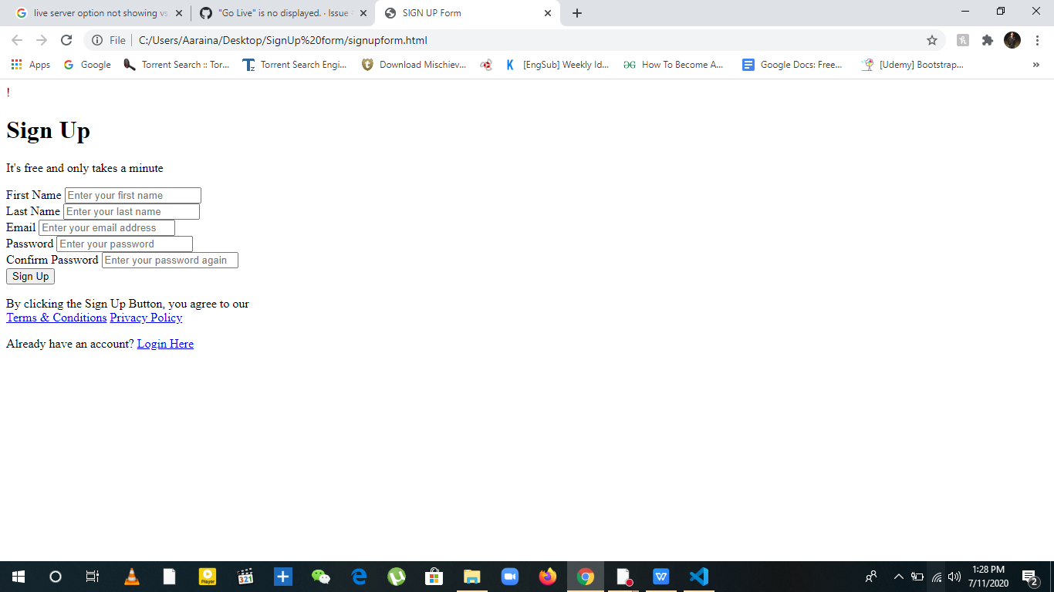

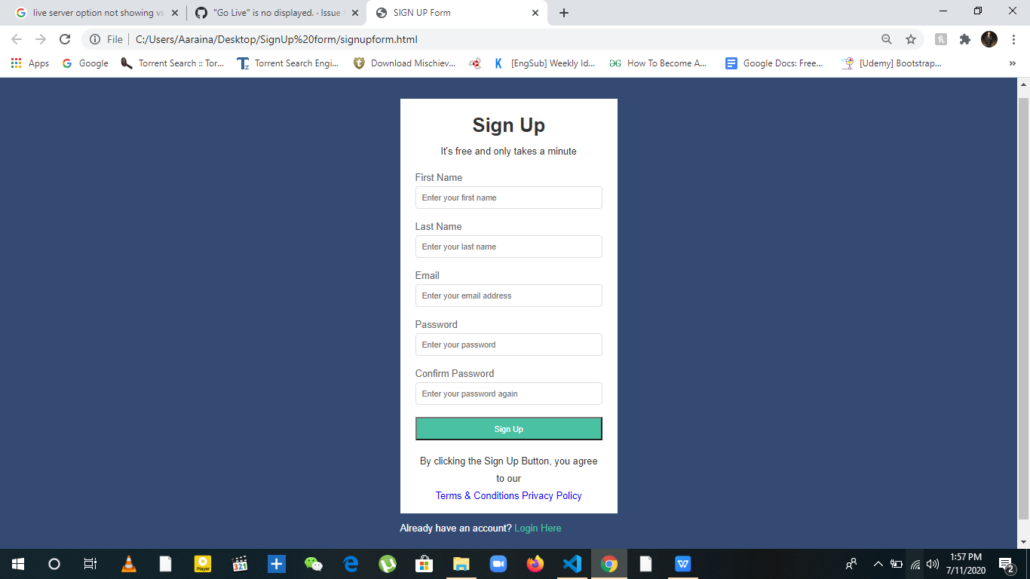

**B.3 Conclusion:**

*Through this experiment, we have learned about various tags used in HTML files and how several webpages are linked to each other to create a website platform.*

**B.3 Observations and Learning:**

**B.4 Question of Curiosity**

Q.1. Describe all basic tags used by you in the above experiment with syntax and an example.

Ans 1) Tags used in the above experiment are:

1. Meta Tags: **<meta name="description" text="Signup Form"> ,** Meta tags are used for SEO purpose. Here Meta tag describes the description of the webpage which is a signup form.
2. Link Tag: **<link href = "signupform.css" rel="stylesheet" text="css">,** the link tag is used to
3. Head Tag: <head> </head> , Head tag includes all the meta tags, link tags, and title tag of the signup form.
4. Body Tag: <body> </body>, Body tag inlcudes the paragraph tags, form tag, a tags, button tags.
5. Title Tag:  **<title>**

**SIGN UP Form**

**</title> ,** title tag is used to add Sign Up title to the webpage.

1. Paragraph Tag: <p> </p>, Used to add descriptive paragraphs on the webpage.
2. Form Tag: <form> </form>, Used to create a form layout for the webpage.
3. Label Tag: **<label for="Password">Password</label> ,** Label tag is used for adding labels of specific attribute to the form.
4. Button Tag:  **<button type="submit" class="btn">Sign Up</button> ,** Button tag is used to create a button attribute in the form.
5. Footer Tag: <footer> </footer>, The footer tag is used to display the contents on the bottom of the webpage, below the body section.